AI Use Declaration Form
Course: Introduction to Artificial Intelligence
Lab Title: Lab 1 Part A — Uninformed Search Algorithms
Student Name: ____________Prince Mwinefobon____________________________________
Student ID: _____________54572028_________________________________________
GitHub Repository Link: _______https://github.com/Prina5/Mwinefobon_prince_lab0____________________________________
Date Submitted: _________June 5, 2026_________________________________________

1. AI Use Summary
Question | Student Response
Did you use any AI tool for this lab? | Yes
Estimated percentage of the work influenced by AI | 20%
Did you attach evidence of AI use where applicable? | No

2. Details of AI Use
Complete the table below for each AI tool used. Add more rows where necessary.
Name of AI Tool Used | Purpose for Using the Tool | Prompt or Instruction Given to the Tool | Part(s) of the Work Influenced by the Tool | How I Verified, Edited, or Improved the AI Output
Chat GPT | Understanding the concepts that were not in the lab support | How do I do this or that on an instance of a question, resolving errors in the code | Question 7, Correlation, and Linear Regression | On the question seven the CLV initially did not specify the purchase frequency, hence I edited it to capture the right columns and be able to meets the demands of the question

3. Attachment of AI Output Evidence
Where required, attach evidence of AI use. Tick all that apply. Add more rows where necessary.
Evidence Type | Attached? (Yes, No, N/A) | File Name
AI-generated draft | No
Prompt history | No
Screenshot of AI interaction | Yes
Exported AI conversation | No
AI-generated code snippet | Yes
Revised version showing student input | No

4. Student Declaration
I declare that:
Declaration Statement | Response (Yes/No)
The submitted work is my own work. | Yes
Any use of AI tools has been clearly declared in this form.
The prompts, instructions, and AI-generated outputs have been disclosed where applicable. | No
I reviewed, tested, edited, and improved any AI-generated content before submission. | No
My AI usage does not exceed 25% of the entire work. | Yes
I understand that undeclared or excessive AI use may be treated as academic misconduct. | Yes

Student Signature: ______________________P.M_____________________
Date: ________________________June 5, 2026___________________

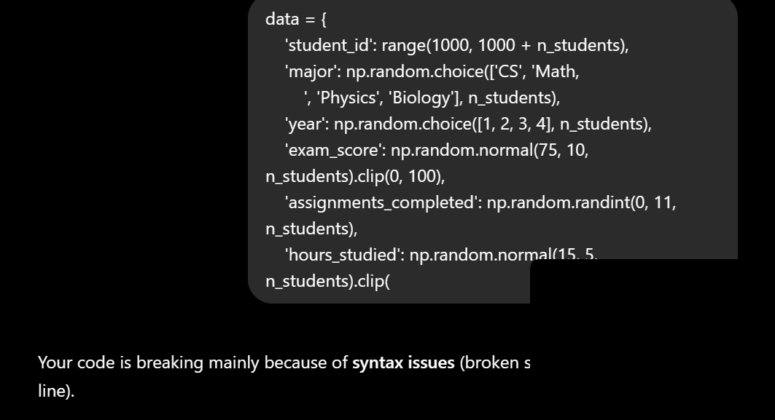
Code Snippet: how can the clv become better

